WHS RISK ASSESSMENT FORM
If you are assessing hazards and risks that are associated with working or learning activities or environments, including equipment, use one of ACU’s two WHS risk assessments forms:
- Use this WHS Risk Assessment Form to assess general activities or working or learning environments; OR
- Conduct the assessment using the WHS Risk Assessment Form for Practical Activities/Research whenever you are determining the hazards and risks that are associated with practical activities or research.
Alternatively, use the Chemwatch Risk Management or Credo Modules (chemical mixing processes) to assess the hazards and risks that are associated with specific hazardous chemicals.
WHS risk assessments should be conducted whenever it is not immediately clear what hazards, risks and/or solutions are associated with safely undertaking an activity. Page 3 provides more guidance about conducting these assessments.
Section 1: Describe What is Being Assessed
Assessment Date: ____/_____/______ | Completed by (incl. work area): | Campus/Location (incl. level and room):
Describe what is being assessed for hazards:

The following people were consulted during this risk assessment:

Potential impacts that may result in injuries, property damage or the damage to the natural environment:

Photos/Diagrams of the Hazard (s)
Section 2: Assess the Hazards and Risks
Formally assess hazards and risks, below, and refer to Appendix A and other resources for guidance.

Risk Analysis |  |  | Risk Analysis |  | Risk Treatment (Future)
Process or Activity  Describe the process, activity, facility or event that may lead to hazard or risk exposures. | Hazard(s)  Outline the situation or thing that has the potential to harm a person e.g. chemicals, a repetitive job, workplace stress, wet footpaths. | Risk  Describe the nature of the potential harm in terms of injuries and/or environmental or property damage e.g. could result in back injuries | Existing Treatments (risk controls)  Identify any existing treatments that are applied to minimise or eliminate hazard exposures and the risk. | Risk Rating  Calculate the risk rating that is associated with applying any existing treatments (see Appendix B). | Future Treatments  Place a higher priority on immediately actioning higher level risks, using higher level treatments (Refer to Appendix A). | Action Owner  (Responsible for actioning treatments) | New Risk Rating  (applying existing and future treatments)
 |  |  |  | Likelihood:  (Insert rating)  Consequence:  (insert rating)  Risk Rating:  (insert rating) |  |  | Likelihood:  (Insert rating)  Consequence:  (insert rating)  Risk Rating:  (insert rating)
 |  |  |  | Likelihood:  (Insert rating)  Consequence:  (insert rating)  Risk Rating:  (insert rating) |  |  | Likelihood:  (Insert rating)  Consequence:  (insert rating)  Risk Rating:  (insert rating)
 |  |  |  | Likelihood:  (Insert rating)  Consequence:  (insert rating)  Risk Rating:  (insert rating) |  |  | Likelihood:  (Insert rating)  Consequence:  (insert rating)  Risk Rating:  (insert rating)
 |  |  |  | Likelihood:  (Insert rating)  Consequence:  (insert rating)  Risk Rating:  (insert rating) |  |  | Likelihood:  (Insert rating)  Consequence:  (insert rating)  Risk Rating:  (insert rating)

Section 3: Gain Authorisation for this WHS Risk Assessment

Required control and/or actions (incl. any costs) | Action Owner (Person/s implementing controls) | Due Date | Date Applied | Verified by
Is the risk acceptable/Not acceptable? (please circle) | Approved by (Name and Job Title of Nominated Supervisor/Manager): |  |  | Signature:
Executive Planning Group sign-off (If recommended Controls have budgetary implications or risks are rated as High)

Executive Planning Group Member’s Name:_________________________________________Signature:__________________________________Date: ___/___/_____

Please retain a copy of this WHS risk assessment and submit a copy to Service Central using the general enquiry form.

How to Use this Risk Assessment Form

- Fill out Section 1 and attach any photographs that illustrate the hazard(s) that are being assessed for risks.
- Section 2: Assess the hazards and risks, in consultation with your Nominated Supervisor or Manager, associated with the process, activity or other aspects of the working and learning environment that you are assessing. Use higher level treatments (see Hierarchy of Risk Control on right) to manage higher level risks, whenever it is practical.

- In Section 3 of this form, list the treatments (risk controls) that will be applied to manage the risk (s) and the Action Owner, who will be responsible for implementing them. Gain endorsement for the WHS risk assessment from your nominated Supervisor/Manager and Executive Planning Group member or Executive Planning Group (non-academic organisational units), whenever the recommended controls have budgetary implications and/or risks are rated as High, and send the completed form to your local Facilities Manager and HR via Service Central using the general enquiry form.
- Consider the appropriate levels of supervision, training and instructions that should be developed to ensure that new and future treatments are applied.
- Enter the risk identified, treatments and other information into your organisational unit risk register if specific treatments are applied to manage risks.

- Human Resources will enter any risks into local Campus WHS Risk Register whenever risks have campus-wide impacts.

- Local Campus WHS Risk Registers should be sent to the local WHS Committee by Human Resources for an annual review that will be completed by 24 December, each year.

Table 1: Hierarchy of Risk Controls (treatments)
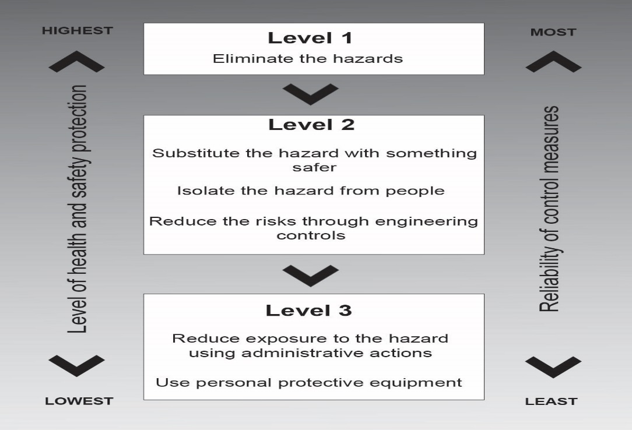

Figure 1: Hierarchy of Risk Control
APPENDIX A: SOME EXAMPLES OF HAZARDS TO CONSIDER

Common Hazards
Uneven, angled or wet surfaces (could result in slips/falls) | ☐ | Handling heavy, unstable or awkward objects/loads | ☐ | Exposure to infectious diseases or security hazards | ☐
Sharps or needle exposures | ☐ | Contact with sharp objects/edges | ☐ | Poor posture and repetitious movements | ☐
Animal, insect or spider bites/stings | ☐ | Exposure to blood and other fluids | ☐ | Temperature extremes or uncomfortable temperatures | ☐
High levels of exposure to the sun | ☐ | Traffic hazards | ☐ | Inadequate lighting | ☐
Chemical exposures | ☐ | Improperly adjusted workstations and chairs | ☐ | Commuting hazards | ☐
Exposure to violence or traumatic events | ☐ | Unstable chemicals | ☐ | Damage to electrical parts or power cords | ☐
Working alone | ☐ | Ingress of water into electrical components | ☐ | A lack of knowledge about safe work processes | ☐
Hazards related to construction projects
Spills on floors or tripping hazards, such as blocked cords running across the floor | ☐ | Lack of isolation between building or maintenance works and pedestrians | ☐ | Working from heights, including ladders, scaffolds, roofs or any raised work area | ☐
Fatigue | ☐ | Frequent lifting | ☐ | Confined spaces | ☐
Electrical hazards | ☐ | Moving traffic hazards | ☐ | Falling objects, including unsecured objects | ☐
Constant loud noise | ☐ | Contact with moving plant/parts | ☐ | Unguarded machinery and moving parts | ☐
Defective tools and plant, including items that are not locked out/tagged out (unsafe to use but still accessible) | ☐ | Exposure to liquids like cleaning products, paints, acids and solvents | ☐ | Atmospheric contaminants such as dust, synthetic and mineral fibres | ☐
Excavations and trenches | ☐ | Lifting and pushing | ☐ | Exposure to hazardous substances | ☐
Hand tools | ☐ | Lack of training in safe systems of work | ☐ | Identified hazards have not been assessed for risks | ☐
Chemical Hazards
Health Effects |  | Hazardous Reactions |  | Evidence of Exposure
Acute toxicity (short term) | ☐ | Explosive (chemical may have changed form) | ☐ | Presence of dust/odours | ☐
Chronic toxicity (long term) | ☐ | Flammable | ☐ | Leaks/spills/residue | ☐
Corrosive | ☐ | Spontaneous reactivity | ☐ | Worker symptoms | ☐
Irritant | ☐ | Water reactive | ☐ | Direct contact | ☐
Sensitiser | ☐ | Oxidiser | ☐ | Routes of Exposure
Mutagen | ☐ | Other dangerous reactions | ☐ | Inhalation | ☐
Teratogen | ☐ | Duration of Work/Day – Related to Exposures |  | Ingestion | ☐
Asphyxiate | ☐ | Infrequent | ☐ | Skin absorption | ☐
Radioactivity | ☐ | 0 – 15 minutes | ☐ | Eye contact | ☐
Infectious | ☐ | 16 minutes – 1 hour | ☐ | Injection/needle skin | ☐
Also consult manufactures’ labels, Safety Data Sheets, Chemwatch and labels. | ☐ | 1 – 4 hours | ☐ | Form  Liquid, powder, paste, gas, concentrate, dilute, other (has it changed form?) | ☐

APPENDIX B: ASSESSING THE RISK RATING
Calculate a Risk Rating, using the Risk Rating Table (Below), by:
- Choosing a Likelihood Rating (almost certain to rare), from the table below, based on your assessment of the likelihood of exposure(s) to the hazard(s)
- Select a Consequence Rating, from the table below, which reflects your assessment of the consequences of people being exposed to the hazard(s).
- Line up the intersection point between the Consequence Rating and Likelihood Rating to determine the risk rating e.g. If you assessed the consequence to be Moderate and the likelihood rating to be Almost Certain, the risk rating is High (30).
- Refer to the Hierarchy of Risk Control to assist you to choose risk controls to manage hazards and associated, which should be documented in Section 3. Higher level controls should be selected to manage higher level risks.
Likelihood Ratings | Consequence Ratings
Almost Certain: Is expected to occur in most circumstances per month  Likely: Will probably occur at least once (between once per month and once per year)  Moderate: Might occur at some time (between once per year and once in 5 years)  Unlikely: Could occur at some time (between once in 5 years and once in 20 years)  Rare: May occur in exceptional circumstances (once in more than 20 years) | Catastrophic: Could result in death, permanent total disabilities or severe injuries affecting multiple persons  Major: Could result in permanent partial disabilities or injuries or illness resulting in hospitalisation of multiple persons  Moderate: Could result in injury or illness resulting in Lost Time Injury (LTI)  Minor: Minor injury or illness not resulting in lost work day  Insignificant: Unlikely to result in an injury
Likelihood  Rating | Consequence Rating
 | Insignificant  (1) | Minor  (3) | Moderate  (10) | Major  (30) | Catastrophic  (100)
Almost Certain (3) | Moderate  3 | Moderate  9 | High  30 | High  90 | High  300
Likely (1) | Moderate  1 | Moderate  3 | Moderate  10 | High  30 | High  100
Moderate (0.3) | Low  0.3 | Moderate  0.9 | Moderate  3 | Moderate  9 | High  30
Unlikely (0.1) | Low  0.1 | Low  0.3 | Moderate  1 | Moderate  3 | Moderate  10
Rare (0.03) | Low  0.03 | Low  0.09 | Low  0.3 | Moderate  0.9 | Moderate  3

APPENDIX C: PLACING WHS RISKS ON ORGANISATIONAL UNIT RISK REGISTERS
Refer to the guidance, below, to assist you to enter the information about WHS risks (which may already have been completed within previous sections of this form) into organisational unit Risk Registers.
Insert the date that the treatment was/will be applied.

Risk Identification |  | Risk Analysis |  |  |  | Risk Treatment (Future)
Risk Event | Risk Owner | Causes | Impacts | Existing Treatments | Risk Rating | Future Treatments | Action Owner | Resolution/  Review Date
Insert the name and position title of the Risk Owner that was nominated within Section 3 [usually a Member of the Senior Executive (University Risk Register) or Member of the Executive (Organisational Risk Register)] |  |  |  |  | Likelihood  (insert)  Consequence  (insert)  Risk Rating  (insert)
 |  | Provide more comprehensive details about the risk to people, property and/or the environment. |  |  | Likelihood  (insert)  Consequence  (insert)  Risk Rating  (insert) | Insert the name of the Action Owner (and their position title) who was nominated in Section 3
 | Provide a ‘high level’ summary of the Risk to people, property and/or the environment and the location or extent of this exposure to hazards and risks. This information can be sourced from the risk information in Section 2. | Summarise the activities or processes that could result in hazard exposures, occurring. e.g. walking down the North Sydney Library stairs with books could result in trip and falling objects hazards. This information was outlined in the Process or Activities column in Section 2. |  | Insert information about the Existing Treatments, which is detailed in Section 2. | Likelihood  (insert)  Consequence  (insert)  Risk Rating  (insert) |  | Insert information outlined in the Future Treatments column that was detailed in Section 3. Also insert the New Rating, which was detailed in Section 2.
Likelihood
(insert)
Consequence
(insert)
Risk Rating
(insert)

