Theory of Change
Guidance for researchers

WHAT IS A THEORY OF CHANGE?
A Theory of Change (ToC) is a roadmap for planning, implementing, and evaluating the impact of a research project. It is a systematic and visual representation of how and why a program or initiative is expected to create change. The comprehensive description of the outcomes, goals, and activities necessary to achieve a desired change in a particular context enables researchers to articulate their vision, identify potential barriers and risks, and monitor progress towards achieving the intended outcomes. A ToC can be developed for all project types – research programs, one-off projects, events, policy, strategy level planning or organisation wide.

WHY DEVELOP A THEORY OF CHANGE?
A ToC is a useful framework when planning project or program strategy to identify the current situation (inputs, needs and opportunities), the intended situation (project outcomes) and what needs to be done to move from one to the other. This can facilitate the design of specific and realistic goals, clarify accountabilities and establish a shared understanding of the plans a project will use to achieve its goals. By developing a diagram or written description of the strategies, actions, conditions and resources that facilitate change and achieve outcomes, researchers can explain why they think a particular set of activities or actions will lead to a desired change.
Since people feel a greater ownership of things they have helped to create, a comprehensive ToC developed with stakeholder participation can also facilitate the achievement of common goals. The table below outlines the benefits of developing a ToC early in research-related projects.
Theory of Change - benefits for researchers
Planning participatory research | Helps researchers articulate their research question and develop a research plan that is focused on achieving specific outcomes in collaboration with stakeholders. By identifying the underlying assumptions, causal pathways and outputs, researchers can ensure that their research methods and data collection strategies are aligned with their short- and long-term research goals.
Implementing interventions | The planned roadmap with activities, roles and responsibilities and the analysis of assumptions and risks facilitates the implementation of interventions.
Evaluating impact | Facilitates evaluation of a project’s impact. By tracking progress towards specific outcomes, researchers can identify what is working well and where improvements can be made. It also allows researchers to identify and change areas of strength and weaknesses and previous assumptions along the project journey.
Communicating findings | ToC is a useful tool for communicating research findings to stakeholders, including funders, policymakers, and the public. By presenting a clear and concise summary of the research process and the underlying assumptions, researchers can help stakeholders understand the significance of their research and its potential impact.

WHAT IS THE PROCESS FOR DEVELOPING A THEORY OF CHANGE?
Developing a ToC is an iterative and collaborative process that involves stakeholders at all stages. It requires a deep understanding of the problem, a clear vision of the desired future state, and comprehensive development of the causal pathways that link strategies to outcomes.
The process for developing a ToC typically involves the steps outlined in the following table. These components can then be incorporated into a comprehensive narrative and/or a visual diagram to demonstrate the rationale behind an evidence-based, stakeholder-informed, and changed-focused project. Include an introduction describing its development, and acknowledging the contributors.

STEPS FOR DEVELOPING A THEORY OF CHANGE
Steps | Instructions | Example: ToC for preventing child maltreatment in Australia
1. Define the problem | Define the problem the ToC seeks to address and its root causes. Include an understanding of the context, stakeholders and beneficiaries. Note any references to existing evidence, including any relevant research. This step is often referred to as a 'situational analysis'. | High rates of child maltreatment (including neglect and abuse) in Australia, as identified by the Australian Child Maltreatment Study.  Limited chid maltreatment support in health services and communities.
2. Develop a vision | Clarify the desired long-term change for beneficiaries. This might be improvements for a population (improved health, safety, well-being, capabilities, behaviours); or structural (stakeholders’ relationships; federal, state or local policies or practices). It should be based on current knowledge and context, and collaboratively developed with stakeholders to reflect their aspirations and ensure collective commitment to achieving the vision over a defined timeline. | To prevent child maltreatment by promoting positive parenting practices, increasing support for families, and addressing systemic factors that contribute to maltreatment, such as transforming the community's attitudes towards child maltreatment.
3. Map stakeholders | The Influence-Interest Matrix can help you prioritise stakeholder engagement strategies (those in the high interest category are more likely to engage with your research and can advocate for impact among the hard-to-reach stakeholders. Identify conflicts and alliances to inform your engagement strategy. | Easy to reach stakeholders: funders, partners and beneficiaries (families)  Hard-to reach influential stakeholders: policy makers
4. Map the causal pathway | Then identify how the vision will be realised, or the steps that must occur for the project to achieve the desired outcomes, by developing the following components:  - Inputs – the financial, human, and material resources required to implement the activities  - Activities - evidence-based, feasible interventions to realise the vision (e.g. providing services, influencing social structures, research or collaborative efforts).  - Outputs – the project ‘products’, i.e. the resources and knowledge directly resulting from the activities  - Outcomes - clearly defined short- and long-term measurable changes, aligned to the vision. Include:  - direction of change (increased, decreased, maintained, improved, greater, fewer)  - what changes (attitude, practice, perception, knowledge, skill, behaviour, health, policy, systems)  - for whom (individuals, participants, populations, communities, client, organisation, structures)  - Impact - the high-level desired change the project sets out to make (linked to vision)  The pathway should describe how inputs are transformed into outcomes, via the project's outputs. Each outcome should indicate how it contributes to the overall impact. | - Inputs: funding from government and non-government sources, staff with expertise in child development, family support, and evaluation and community partnerships. The project will also need to establish partnerships with community organisations and service providers.  - Activities: parenting education and support programs, family counselling and therapy, and advocacy efforts to address systemic factors such as poverty and social isolation.  - Outputs: increased parental knowledge and skills, improved access to support services, and increased community awareness about child maltreatment.  - Outcomes: improved parent-child relationships, improved child well-being and reduced child maltreatment rates.  - Impact: reduced rates of child maltreatment in the community and improved children and families' well-being.
5. Develop indicators | Develop indicators to measure progress on desired outcomes. They should be specific, measurable, achievable, relevant, time-bound (SMART) and aligned with the causal pathway. | Increase in families served, changes in parental knowledge/attitudes, reduction in child maltreatment and improvements in child well-being.
6. Plan for evaluation & reflection | Develop a monitoring and evaluation plan to track progress towards achieving the desired change. Identify data sources for each indicator and analysis methods to measure outcome progress. | Evaluation might involve surveys of parents and children, analysis of child maltreatment data, and comparison of outcomes to a control group.
7. Identify assumptions & risks | Consider key assumptions (based on the socio-economic, political, and environmental context) that underpin the causal pathway and risks to achieving the desired outcomes. How can you collectively address them? They may relate to implementation, stakeholder engagement, or external factors. | Assumptions might include the availability of funding and community support for the program. Risks might include staff turnover or changes in government policy.
8. Share and refine the ToC | This is an iterative process requiring review and adaptation based on new information and changing contexts. Validate and refine it with stakeholders, analyse favourable and unfavourable conditions and review and document underlying assumptions along the way about the strategies and outcomes. | Communicate to funders, partners and stakeholders to provide a clear understanding of the vison and strategies. The ToC might be refined based on stakeholders' feedback, participants and evaluation findings, such as adjusting program activities to better meet the needs of families.

STEPS FOR DEVELOPING A THEORY OF CHANGE – VISUAL GUIDE & EXAMPLE LAYOUT
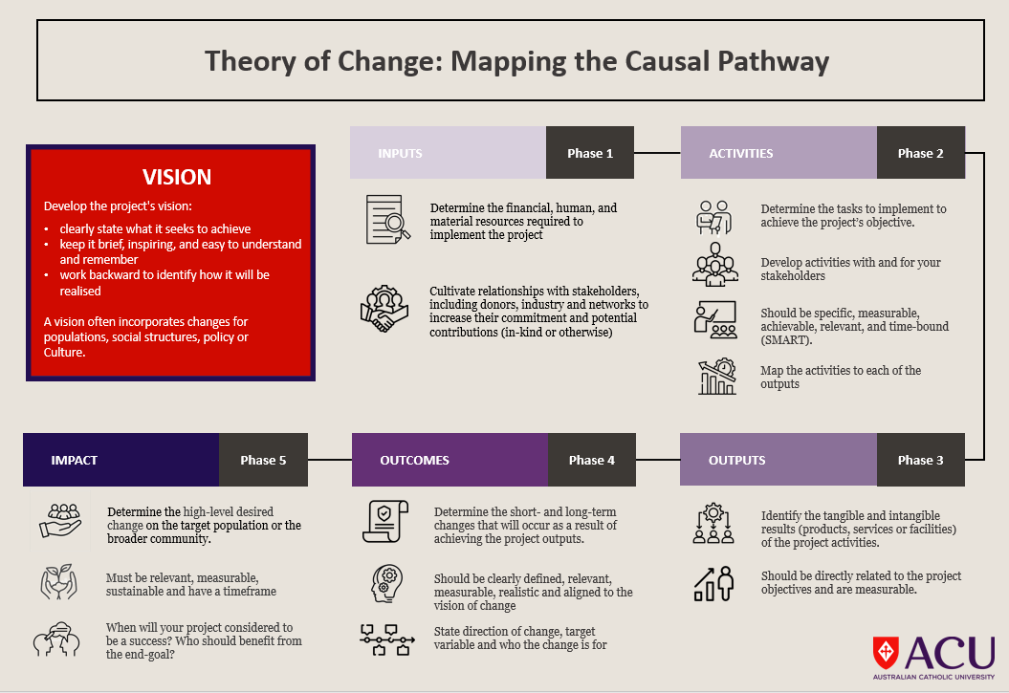

THEORY OF CHANGE PLANNING TEMPLATE
1. What problem are you trying to solve? |  | Develop a situational analysis: what is the problem and its context?
2. What long-term change you desire? |  | A larger societal impact that the project helps contribute to; what will change and how? who are the beneficiaries?
3. Who needs to be involved? |  | Map relevant stakeholders and their potential contributions to develop your engagement strategy
4. How will you solve the problem? Causal pathway required to bring about change |  |  |  |  | 5-6 How will you measure the impact?
With what inputs? | With what interventions? | What are the  project's outputs? | What are the  project's outcomes? | What is the project's measurable impact? | What indicators will you use for each outcome? | How will you collected and analyse indicators data?
Financial resources | Intervention 1 | Output 1 | Outcome 1 | Impact 1 | Indicator 1 to measure effect for Outcome 1 | Data source, collection and analysis for Indicator 1
Human resources | Intervention 2 | Output 2 | Outcome 2 | Impact 2 | Indicator 2 to measure effect for Outcome 2 | Data source, collection and analysis for Indicator 2
Material resources | Intervention 3 | Output 3 | Outcome 3 | Impact 3 | Indicator 3 to measure effect for Outcome 3 | Data source, collection and analysis for Indicator 3
In-kind resources | Intervention 4 | Output 4 | Outcome 4 | Impact 4 | Indicator 4 to measure effect for Outcome 4 | Data source, collection and analysis for Indicator 4
7. What are the related key assumptions and risks along the way?
Assumptions:  Risks and mitigations: | Assumptions:  Risks and mitigations: | Assumptions:  Risks and mitigations: | Assumptions:  Risks and mitigations: | Assumptions:  Risks and mitigations: | Assumptions:  Risks and mitigations: | Assumptions:  Risks and mitigations:
8. With whom and how will you share this? |  | Develop your stakeholder engagement strategy

ADDITIONAL RESOURCES
We have selected further online resources to support you in creating a theory of change.

Related documents
- Creating your Theory of Change
- Theory of Change Resources
  - Part one, covered in this entry, introduces theory of change work including its benefits, considerations and limitations.
  - Part two delivers step-by-step guidance — including considerations, exercises and examples — to aid program leaders in articulating and documenting a useful, equitable theory of change.
  - Part three offers fillable theory of change templates that can help teams record their theory of change components, assumptions and audiences.
  - Part four offers examples of theory of change models.

Related websites
- BetterEvaluation is a leading online resource for evaluation theory and practice. Includes a detailed guide to developing a Theory of Change and examples, case studies, and templates.
- The Aspen Institute Includes a comprehensive guide to developing a Theory of Change & examples.
- The Evaluation Center at Western Michigan University Resources & support for evaluation research.
- Innovation Network & The Center for Theory of Change - nonprofit organization that provides resources for social change initiatives.
- The International Initiative for Impact Evaluation (3ie) - global organization promoting evidence-based policymaking & development.
- The World Bank - global organization that provides resources & support for development initiatives. Website includes a guide to developing a Theory of Change, examples & templates.
- USAID - guide to developing a Theory of Change, examples & templates specific to international development projects.

Related educational videos
- The Theory of Change: A Framework for Planning and Evaluation by BetterEvaluation - overview of the Theory of Change, its components & applications in program planning and evaluation.
- Creating a Theory of Change by the Innovation Network provides a step-by-step guide to developing a Theory of Change, including tips for identifying outcomes, indicators, and activities.
- What is a Theory of Change? by the Center for Theory of Change introduces the Theory of Change framework, its components, and its uses in program planning and evaluation.
- Theory of Change by the International Initiative for Impact Evaluation (3ie) provides an overview of the Theory of Change framework, its benefits, and its uses in international development programs. It also includes examples and case studies.
- Developing a Theory of Change by the Evaluation Center at Western Michigan University provides a step-by-step guide to developing a Theory of Change, including tips for identifying assumptions, pathways of change, and outcomes.
- What is a Theory of Change and How Do We Use It? by the World Bank provides an overview of the Theory of Change framework, its benefits, and its uses in international development programs. It also includes examples and case studies.
- How to Develop a Theory of Change by USAID provides a step-by-step guide to developing a Theory of Change, including tips for identifying assumptions, outcomes, and indicators. It also includes examples and case studies.
- Creating a Theory of Change for Your Nonprofit by Nonprofit Hub provides an overview of the Theory of Change framework, its components, and its uses in nonprofit program planning and evaluation. It also includes examples and case studies.

