Operationalisation of the LEO guidelines

Section = Presentation
Principle = 1
Staff should use approved faculty template/s, which encompass good practice in online visual design and consideration of usability principles.
(a) The university/faculty template/s should relate to both new and existing units.
(b) The university/faculty template/s should address best practice online visual design and usability elements such as use of headings, fonts, colours, chunking of information, scrolling, use of white space etc.
(c) Staff should ensure a new unit conforms to the current university/faculty template/s, when rolling over a unit.

FLB
Faculty of Law and Business units should use one of the FLB Digital Core Templates. Information about the Digital Core Templates, including how to access them, can be found in the Unit Design section (https://leo.acu.edu.au/course/view.php?id=10726&section=3) of L&T Connect (https://leo.acu.edu.au/course/view.php?id=10726), the faculty PD unit. See especially the LEO Book resource Digital Core Explained (https://leo.acu.edu.au/mod/book/view.php?id=1461790).

FHS
Faculty of Health Sciences staff are asked to select the appropriate faculty template in LEO when creating a unit, as depicted in the image below.
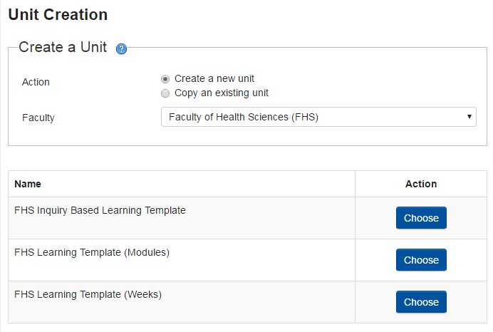

FEA
Faculty of Education and Arts staff should first meet with their teaching team including the National Unit Coordinator to begin planning the unit material. The teaching team are asked to select the FEA National Unit Guide template in LEO when creating a unit, as depicted in the image below and add all campus cohorts and semesters.
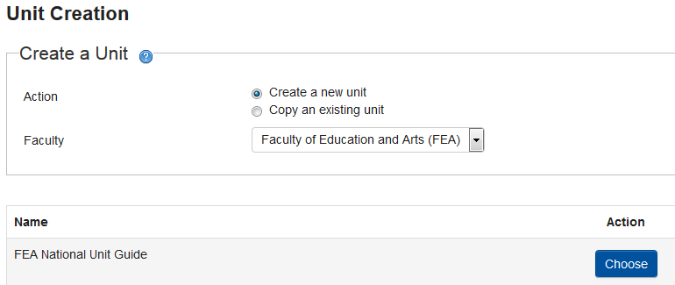

FTP
FTP staff are to refer to the FTP LEO Hub <<insert link to: https://leo.acu.edu.au/course/view.php?id=399 >>

