**Staff Connect**

**User Guide**

**Flexible Working Arrangement**

|  |  |  |  |
| --- | --- | --- | --- |
| Version | Date | STATUS | contributor/s |
| 1 | 21/10/2022 | Published | Chris Wang |
| 2 | 25/10/2022 | Reviewed | Chantal Farah |
| 3 | 16/07/2024 | Updated policy links | Bernardine Lynch |
| 4 | 6/08/2025 | Updated links and images | Bernardine Lynch |
|  |  |  |  |
|  |  |  |  |

Contents

1 Introduction 3

1.1 Purpose 3

1.2 Guide Conventions 3

2 Preparation 3

2.1 Flexible Working Arrangement Policy 3

2.2 Flexible Working Arrangement FAQ 3

2.3 Conversation with Supervisor 3

2.4 Change of Working Hours 4

2.5 Change of Work Location 4

3 Flexible Working Arrangement Form 4

4 Appendix 6

# Introduction

## Purpose

The purpose of this guide is to get the user ready before starting the Flexible Working Arrangement request process in Staff Connect.

## Guide Conventions

**Bold with Underline** indicates a field or phrase used in the form. For example, a section heading, a question or a button.

*Italic with Underline and > mark* indicates the pathway to find the target.

Red font with Underline is an active hyperlink to a web resource.

# Preparation

## Flexible Working Arrangement Policy

Before starting the application, please read the [Flexible Working Arrangement Policy](https://policy.acu.edu.au/document/view.php?id=83).

## Flexible Working Arrangement FAQs

Here are some useful [FAQs on Service Central](https://acu.service-now.com/service_central?id=sc_kb&wgt=all&kb_category=d6d60feedb518850ae96fa0dbf9619d9) for preparing your application.

## Conversation with YOUR Supervisor

Please discuss your situation and proposed arrangements with your supervisor(s).

If you have multiple appointments with ACU and your Flexible Working Arrangement will impact multiple appointments, you will need to raise multiple request forms for each supervisor for approval.

If you have multiple appointments and you need to raise one form for a particular employee number (or need to raise multiple forms), log into Staff Connect, click the grey profile picture at the top right of screen, then select a relevant employee number listed on the **CHANGE EMPLOYEE** screen for the request.

Regardless of the outcome of conversations with your supervisor(s) you are still eligible to submit a flexible working arrangement request via Staff Connect.

## Change of Working Hours

If you are proposing to change or compress your weekly working hours, here are some guidelines from the Enterprise Agreement:

* the maximum number of ordinary hours worked in a day is 9 hours;
* the normal weekly ordinary hours of work shall be 35 hours, with the maximum ordinary hours staff are permitted to work in any week is 45 hours; and
* a staff member will normally work an average of no more than 140 hours over a four-week cycle.

## Change of Work Location

If you are proposing to work off-campus, please ensure you have familiarised yourself and understand the following:

* [Working Efficiently and Safely webpage](https://staff.acu.edu.au/people_and_capability/your-safety-and-wellbeing/workstation-ergonomics);
* Need to log all on and off-campus work related incidents via [riskware](https://staff.acu.edu.au/human_resources/your-safety-and-wellbeing/whs_risk_management/reporting-incidents-and-injuries-on-riskware);
* Your [workers compensation](https://staff.acu.edu.au/human_resources/your-safety-and-wellbeing/whs_risk_management/reporting-incidents-and-injuries-on-riskware/workers_compensation_options) options if/when required;
* [EAP support and wellbeing options](https://staff.acu.edu.au/human_resources/your-safety-and-wellbeing/wellbeing-matters) are available;
* Registered your off-campus device with the [Microsoft Authenticator App;](https://acu.service-now.com/service_central?id=sc_kb_article&sys_id=c31aadeddb459c90f416be37f4961984)
* Access to University IT Systems is requested via [Service Central;](https://acu.service-now.com/service_central?id=sc_kb_article&sys_id=2052f6dadbeb40504a5a61730596195a&table=kb_knowledge)
* Acknowledge personal responsibility for the supply and maintenance of home office equipment.

Below are the mandatory requirements for an off-campus workspace:

* Your home smoke alarm has been tested, within the last 12 months, and is functional.
* Relevant electrical cords and plugs are not frayed or showing signs of damage.
* Your home workstation has/will be configured in an ergonomic way.
* An appropriate chair and desk (a photograph will be uploaded) will be used.
* There are no risks to my safety and wellbeing at this location (e.g., from other people).

To work through the complete WHS checklist, please [download the checklist](https://myacu.sharepoint.com/:w:/s/HR-HumanResources/EWaCo5RMg7NKhR-aWHaYUzUBaQ5SKl7hVHRhMMs20Z65Dw?e=jfzZew).

# Flexible Working Arrangement Form

Log into [Staff Connect](https://selfservice.aurion.cloud/acu/production). Go to *Dashboard > My Forms*.

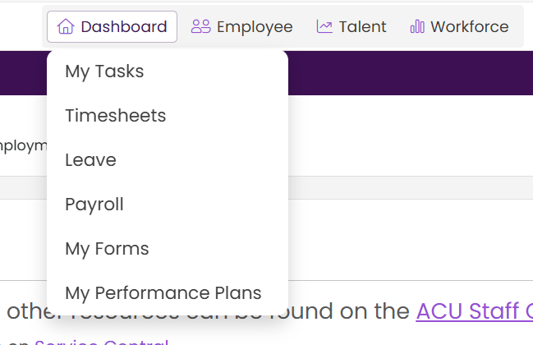

Click the purple **+ Add** button.

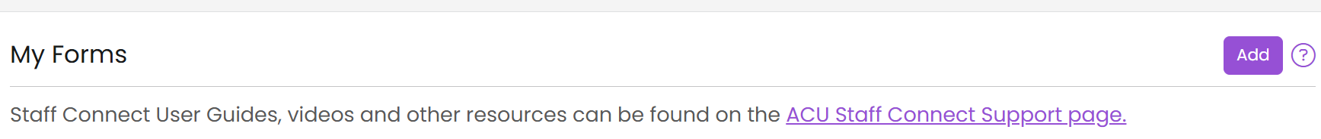

Select **Flexible Working Arrangement (FWA.1)** then click **Next** to start a new request form.

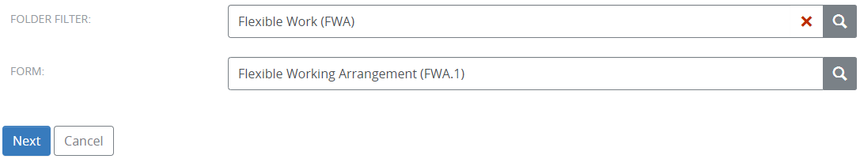

Please follow the in-form instructions while completing the form.

The form will be approved by your supervisor. If you are proposing to change your total working hours, the Member of Executive of your organisational unit will be included in the approval process.

Once it’s approved, People and Culture will apply the arrangement and you will receive an email confirmation. If your working hours change has been approved, and you have future approved leave, you may be required to cancel/reverse the leave and re-submit it, otherwise your leave accruals might be over-deducted.

# Appendix

Screenshots of the Flexible Working Arrangement form.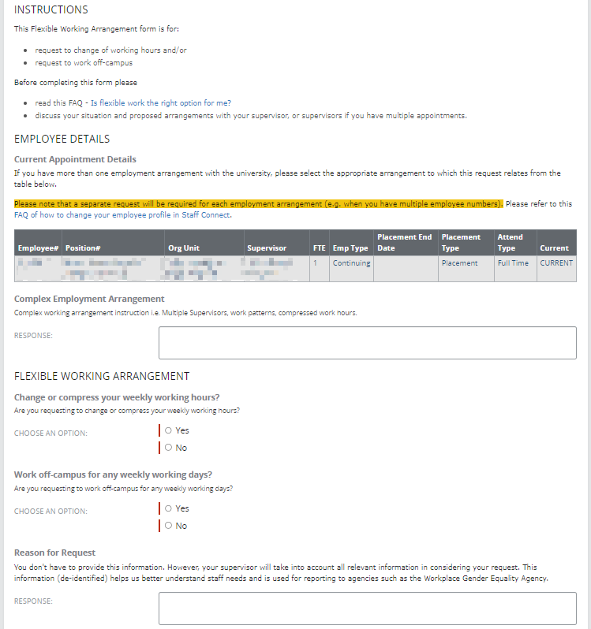 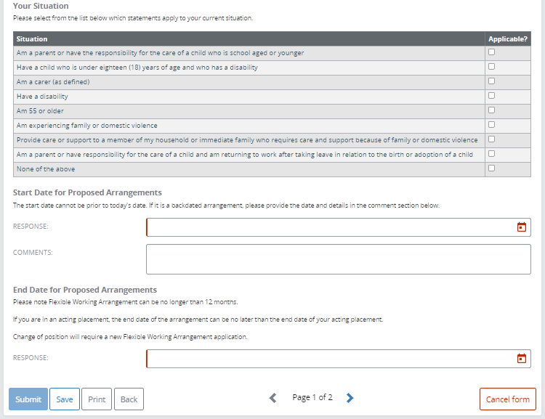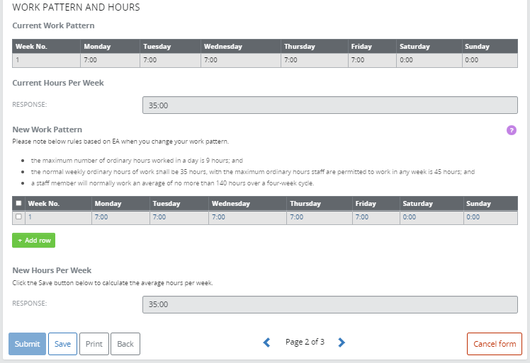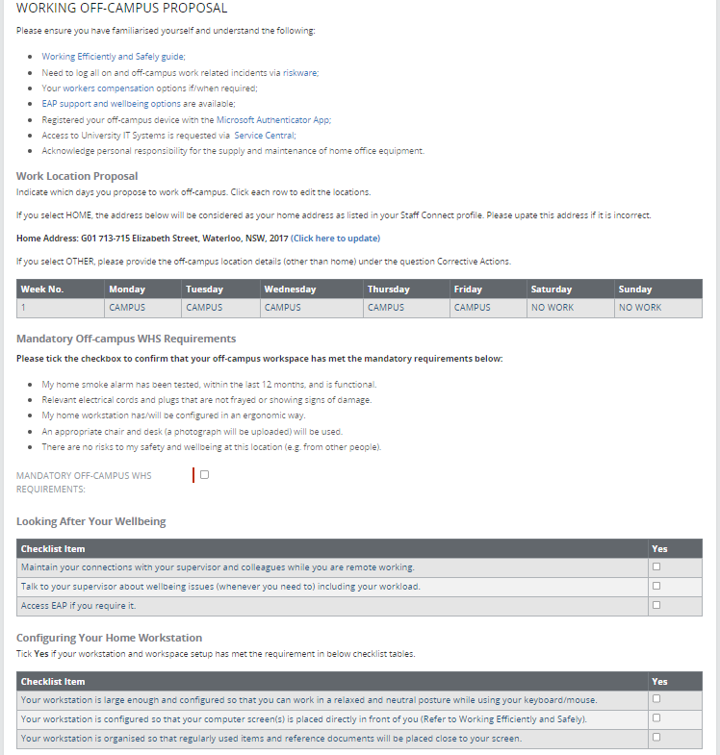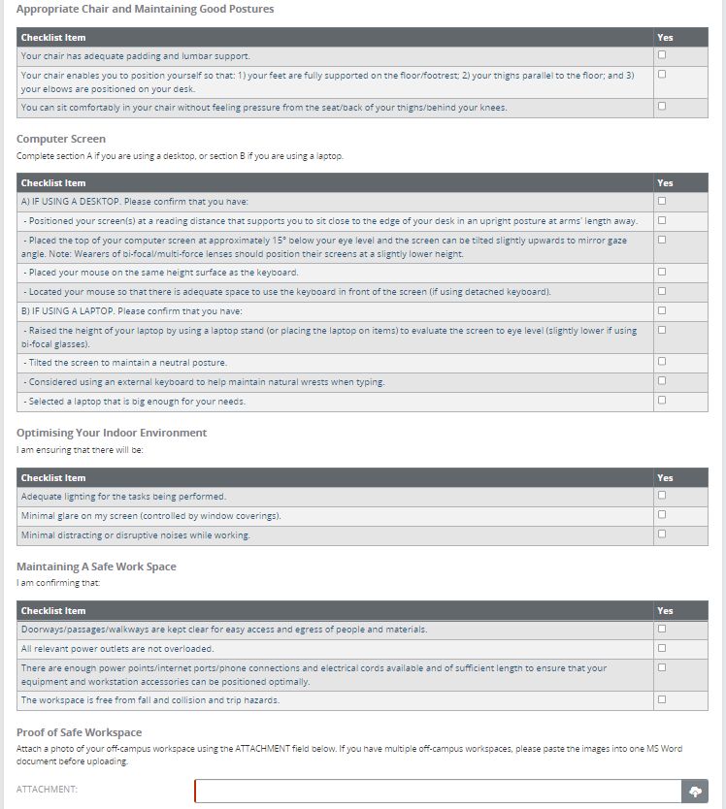 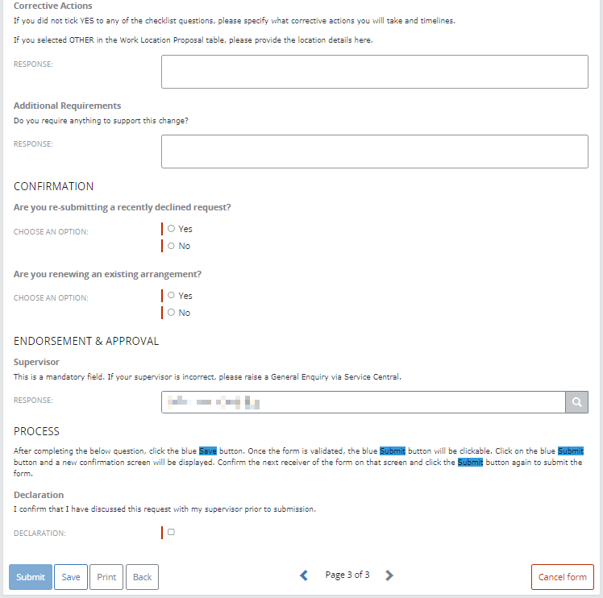

END OF DOCUMENT